*GSR’s please announce speakers*

SURVIVORS GROUP
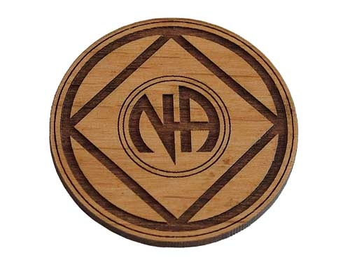
MONTHLY SPEAKER MEETING

Center for Spiritual Living
1195 Clark Street
San Jose, CA 95125

June 1st, 2024 7:00pm

Don C.- 11 years (San Jose)
Leslie G. – 12 years (San Jose)

We have no dues or fees, but are self-supporting through our own contributions. Donations pay for rent and literature

We Recycle Recovery Chips: Please donate your chips

For more information contact –
Tony M - 408.429.5225

